Translingua: AI-Powered Multi-Language Translator
1. INTRODUCTION
1.1 Project Overview
Translingua is an AI-powered multi-language translation system developed to eliminate communication barriers between individuals speaking different languages. In today’s globalized world, effective communication is essential in education, healthcare, business, tourism, and international collaboration. However, language differences often restrict interaction and knowledge exchange.
This project leverages Artificial Intelligence (AI) and Natural Language Processing (NLP) to provide accurate and real-time text translation. The system allows users to input text in one language and receive translated output in another selected language instantly.
The application is designed as a web-based platform with a simple and user-friendly interface. It integrates frontend technologies with a backend server that communicates with an AI-based translation API. The system is scalable and can be enhanced in the future to support voice translation and mobile applications.
1.2 Purpose
The primary purpose of Translingua is to provide an intelligent and efficient translation solution that enables seamless communication across languages.
Objectives of the project include:
- To develop an AI-based language translation system
- To provide accurate and fast translation results
- To reduce dependency on manual translators
- To improve accessibility for students, travelers, and professionals
- To demonstrate the practical implementation of AI in real-world applications
2. IDEATION PHASE
2.1 Problem Statement
Language barriers create major challenges in communication, especially in global business, education, travel, and healthcare. Many individuals face difficulties understanding foreign languages, which leads to misunderstandings and missed opportunities.
Although translation tools exist, some may lack contextual accuracy, speed, or ease of use. Therefore, there is a need for a reliable, AI-powered multi-language translator that provides quick and accurate translations through a simple interface.
2.2 Empathy Map Canvas
Users of this system include students, professionals, tourists, researchers, and businesses.
Think:
Users think about finding a quick and reliable translation solution.
Feel:
They feel frustrated when they cannot understand foreign content.
Say:
“I need a simple tool to translate this text quickly.”
Do:
They search online for translation tools and mobile apps.
Based on these observations, the system must be simple, accurate, and fast.
2.3 Brainstorming
During brainstorming, several ideas were discussed:
- Text-to-text translation
- Speech-to-text translation
- Voice-to-voice translation
- Multi-language support
- Web-based interface
- Mobile application integration
- AI API integration
After evaluating feasibility and impact, a web-based AI-powered text translation system was selected as the final solution.
3. REQUIREMENT ANALYSIS
3.1 Customer Journey Map
- User opens the web application
- User selects source language
- User selects target language
- User enters text in the input field
- User clicks the “Translate” button
- System processes the request
- Translated output is displayed
- User copies or uses the translated text
3.2 Solution Requirement
Functional Requirements
- The system should accept text input from users
- The system should allow selection of multiple languages
- The system should generate translated output
- The system should display results clearly
- The system should allow copying of translated text
Non-Functional Requirements
- High accuracy
- Fast response time
- Secure API communication
- Scalability
- User-friendly interface
3.3 Data Flow Diagram
Level 0 (Context Diagram)
User → Translation System → Translated Output
Level 1
User Interface → Backend Server → AI Translation API → Response Processing → Output Display
This structured flow ensures smooth data communication between user and AI engine.
3.4 Technology Stack
Frontend:
- HTML
- CSS
- JavaScript
Backend:
- Python
- Flask Framework
AI Integration:
- NLP-based Translation API
Tools Used:
- VS Code
- GitHub
- Web Browser
4. PROJECT DESIGN
4.1 Problem Solution Fit
The proposed solution directly addresses communication barriers by providing automated translation services. It is suitable for students, professionals, and travelers who require quick translations.
The system design ensures ease of use and quick response time, making it practical for real-world applications.
4.2 Proposed Solution
Translingua is a web-based AI translation tool that integrates frontend technologies with backend processing and AI API communication.
Working Process:
- User inputs text
- Text is sent to backend server
- Backend calls AI translation API
- API processes and returns translated text
- Output is displayed to user
4.3 Solution Architecture
Components:
- User Interface Module
- Backend Server Module
- AI Translation Engine
- Output Display Module
Architecture Flow:
User → Frontend → Backend → AI API → Backend → Frontend → User
This modular architecture makes the system scalable and maintainable.
5. PROJECT PLANNING & SCHEDULING
5.1 Project Planning
Phase 1: Requirement Analysis (Week 1)
Phase 2: System Design (Week 2)
Phase 3: Development (Week 3–4)
Phase 4: Testing (Week 5)
Phase 5: Deployment & Documentation (Week 6)
Proper scheduling ensured systematic development and timely completion.
6. FUNCTIONAL AND PERFORMANCE TESTING
6.1 Performance Testing
Functional Testing included:
- Testing translation accuracy for multiple languages
- Verifying input handling
- Checking UI navigation
Performance Testing included:
- Measuring response time
- Testing large text inputs
- Ensuring API reliability
- Verifying system stability
The system showed fast response times and consistent performance.
7. RESULTS
7.1 Output Screenshots
The system successfully translated text across multiple languages.
Example:
Input: Hello, how are you?
Output (Spanish): Hola, ¿cómo estás?
The application demonstrated reliable translation capability and fast processing speed.
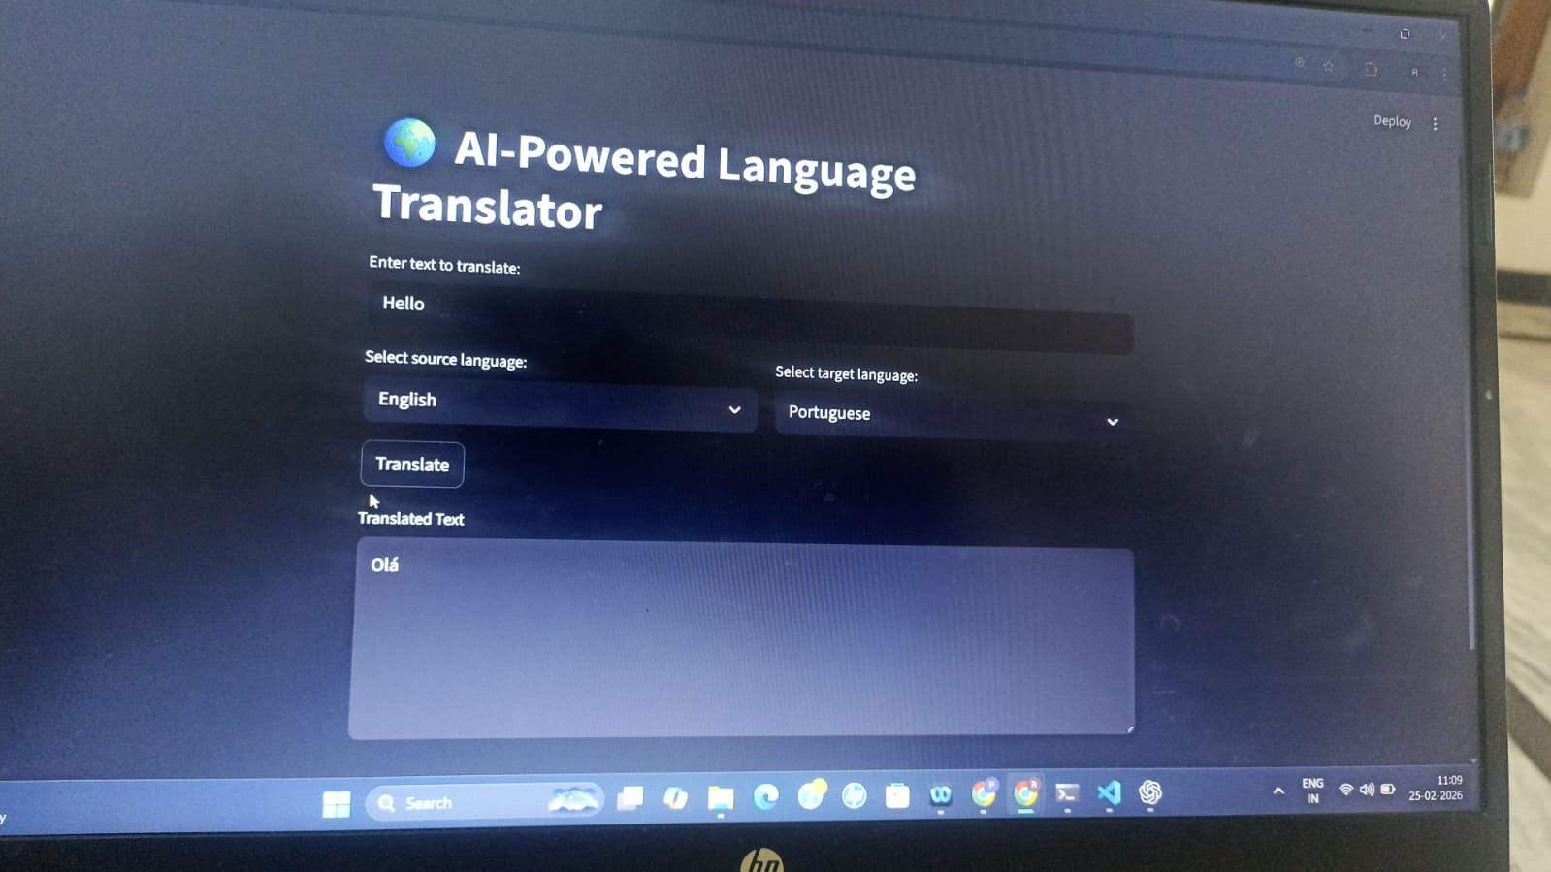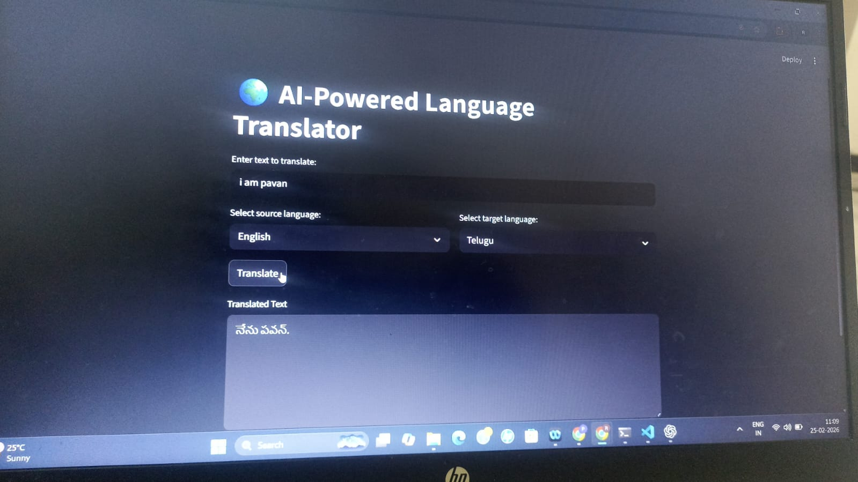
8. ADVANTAGES & DISADVANTAGES
Advantages
- Saves time
- Easy to use
- Supports multiple languages
- Scalable architecture
- Web-based accessibility
Disadvantages
- Requires internet connection
- Dependent on API accuracy
- Minor contextual errors may occur
9. CONCLUSION
Translingua successfully demonstrates the practical application of Artificial Intelligence in language translation. The project achieved its objective of providing fast, accurate, and reliable translations.
The system effectively reduces communication barriers and can be extended for more advanced features in the future.
10. FUTURE SCOPE
Future improvements may include:
- Voice-to-voice translation
- Offline translation support
- Mobile application development
- Context-aware deep learning models
- Integration with messaging platforms
- Real-time chat translation
11. APPENDIX
Source Code: Attach project source files
GitHub Repository: https://github.com/bnpavankalyan2004/translingua
Demo Link:

